**Assignment 4.3**

**Problem Statement 1:**

Write a Java program to display the content of a file in HDFS on screen.

**Program:**

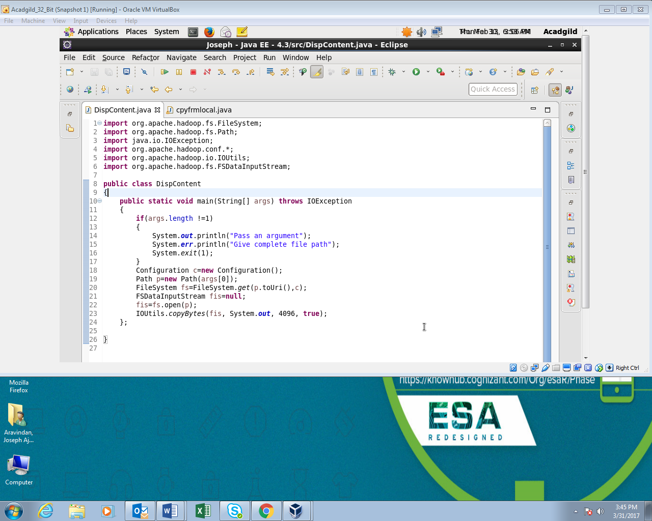

**Output:**

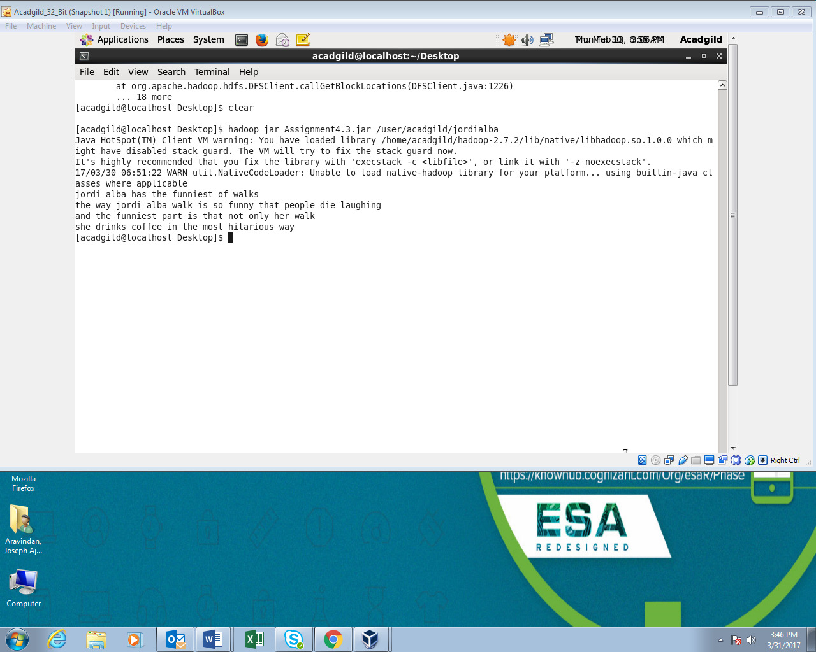

**Problem Statement 2:**

Write a Java program to copy a file from local file system to HDFS.PROGRAM:

**Program:**

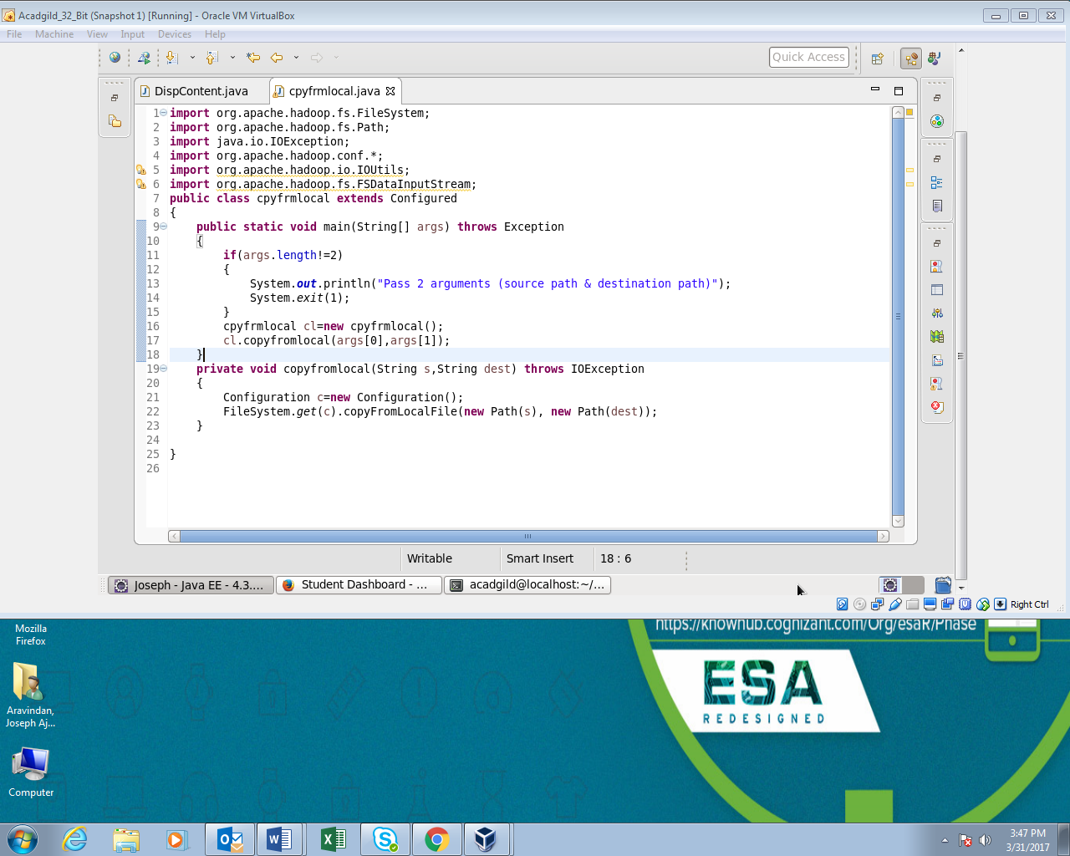

**Output:**

